**Invoice**

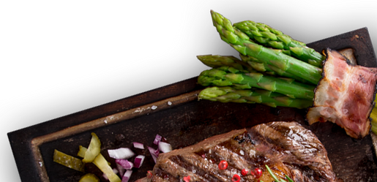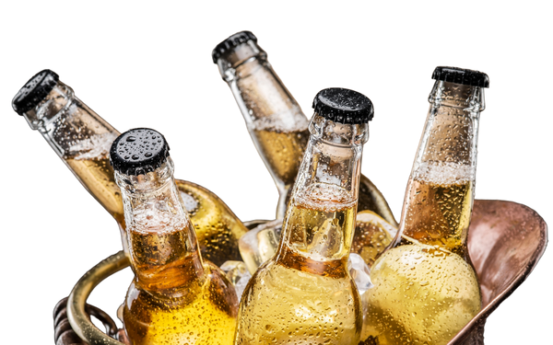

**Invoice to:**

**Invoice no:**

**{{ name }}**

**{{ phone }}**

**{{ Billno }}**

**Date:**

**{{ date }}**

|  |  |  |  |  |  |  |  |
| --- | --- | --- | --- | --- | --- | --- | --- |
| **No** | **Item** | **Price** | **Qty** | **Discount** | **S.Gst** | **C.Gst** | **Total** |
|  |  |  |  |  |  |  |  |
|  |  |  | **{{%tr for item in invoice_list %}}** |  |  |  |  |
| **{{item[0]}}** | **{{item[1]}}** | **₹{{item[2]}}** | **{{item[3]}}** | **{{item[5]}}%** | **{{item[6]}}%** | **{{item[7]}}%** | **₹{{item[8]}}** |
|  |  |  | **{{%tr endfor %}}** |  |  |  |  |
|  |  |  |  |  | Total: |  | **₹{{total }}** |

Bank Info

Account Name: Aaksham Hotel

Bank Account: 123-456-7890